SINGAPORE

If there is one word that best captures Singapore, it is “unique”. A dynamic city rich in contrast and colour, you'll find a harmonious blend of culture, cuisine, arts and architecture here. Brimming with unbridled energy, this little dynamo in Southeast Asia embodies the finest of both East and West. A single day's trail will take you from the past to the future, from exotic ethnic enclave to efficient business centre, from serene gardens to sleek skyscrapers.
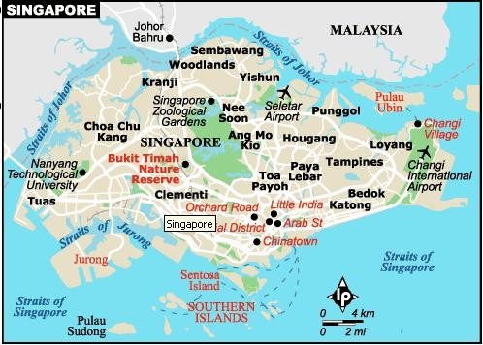

TIME:
Singapore is 2 hours 30 minutes ahead of India.

VISA The visa is to be obtained prior to arrival in the country

CLIMATE:
Singapore's tropical climate is heaven-sent as its 85 miles north of the equator the island is warm and humid all year round, with only slight variations between the average maximum of 31 degrees Celsius and minimum of 23 degrees Celsius. There is no marked wet or dry season as rain falls throughout the year. Singapore receives more rain than usual during the northeast monsoon season from November to January, although humidity is often high during this period of time. Showers are usually sudden and heavy, but also brief and refreshing.

Monthly averages
 | Avg Low in °C | Avg Hi in °C | Avg Precip
January | 24° | 30° | 19.74 cm
February | 24° | 31° | 8.21 cm
March | 25° | 32° | 12.74 cm
April | 25° | 32° | 12.65 cm
May | 26° | 32° | 13.73 cm
June | 26° | 32° | 10.19 cm
July | 25° | 31° | 13.04 cm
August | 25° | 31° | 11.34 cm
September | 25° | 31° | 12.67 cm
October | 25° | 31° | 12.24 cm
November | 24° | 31° | 20.81 cm
December | 24° | 30° | 22.55 cm

CURRENCY:
Singapore's official currency is the Singapore Dollar (SGD), which is divided into 100 cents. The US and Australian Dollars, Yen and British Pound are also accepted in the larger shopping centres. Major credit cards are accepted in hotels, shops and restaurants. ATMs are widely distributed and banks advance cash against the major credit cards. Traveller’s cheques can be cashed at banks or licensed moneychangers and at selected hotels. Banks are open daily, but some do not do foreign exchange on Saturdays.
Tipping is not encouraged as most hotels and restaurants in Singapore already levy a 10% service charge on customers' bills. Tipping is not a way of life in Singapore, but is appreciated for excellent service.

HOW TO GET THERE:
By Air: Singapore Airlines (SQ), Air India (AI), Indian Airways (IC), Jet Airways (9W), Silk Air (MI) fly directly into Singapore.
Most International Carriers like Malaysian Airlines, Sri Lankan, Emirates, Air France, Thai Airways, etc fly into Singapore.

WHEN TO GO:
Go anytime. Climate is not a major consideration, as Singapore gets fairly steady annual rainfall. You may like to co-ordinate your visit with various festivals and events: Thaipusam is one of the most spectacular festivals, occurring around February. If shopping and eating are your major concerns, July is a good month as the Singapore Food Festival and Great Singapore Sale are held then.

GETTING AROUND:
Getting around Singapore is easy, as the island is small and the infrastructure is very well-developed. Many of the places of interest are within walking distance of each other, and the best way to see them is on foot.
Singapore has a comprehensive bus network with frequent services and a convenient Mass Rapid Transit (MRT) subway system. Both are cheap and simple to use. There is also a good supply of taxis and all are metered. There are branches of all major rent-a-car companies here and you can charter bumboats (motorised sampans) to take various tours on the Singapore River. Regular ferry services operate from the World Trade Centre to Sentosa and other islands, while luxurious junk tours can be taken around the harbour.

MRT:
The Mass Rapid Transit (MRT) in Singapore is a modern, air-conditioned passenger train service with stations all over the island. There are three main lines – the North-South line from Marina Bay to Jurong East, the East-West line from Changi Airport/Pasir Ris to Boon Lay, and the North-East line from Harbour Front to Punggol. Trains operate at intervals of between two and a half minutes and eight minutes from 0530 hrs until 0030 hrs daily
Travelling on the MRT is cheap, with rides ranging from SGD 0.80 to a maximum of SGD 1.70.

BUSES:
The SIA Hop-on is a convenient tourist bus service that offers passenger’s unlimited air-conditioned rides to 23 of the most popular attractions located within the shopping, dining, cultural, and entertainment areas in Singapore. SIA Hop-on buses on the city loop operate daily from 9 am to 7.30 pm at 30-minute intervals while the SIA Hop-on Sentosa Shuttle Service runs at 90-minute intervals from 10am to 5.30pm
Non air-conditioned buses: SGD 0.70 to SGD 1.40
Air-conditioned buses: SGD 0.80 to SGD 1.70

TAXIS:
Over 15,000 air-conditioned cabs ply local roads and provide comfortable, hassle-free travel at a very reasonable cost. They can be flagged down 24 hours a day on most roads, with well-marked taxi-stands available outside most major shopping centres and hotels. Fares start from SGD 2.50 for 1km or less.

ELECTRICITY:
The voltage in Singapore is 220-240 volts, AC 50Hz.

EVENTS:
Singapore's polyglot population celebrates a number of festivals and events. Chinese, Hindu and Muslim celebrations follow a lunar calendar so dates of festivities vary from year to year. Chinese New Year, in January or February lasts for 15 days and is welcomed in with dragon dances, parades and much good cheer. Chinatown is lit up and there are fireworks and night markets. The festival of Thaipusam is one of the most dramatic Hindu festivals. Devotees honour Lord Subramaniam with acts of amazing body-piercing. In Singapore, devotees march in procession from the Sri Srinivasa Perumal Temple on Serangoon Rd to the Chettiar Hindu Temple on Tank Rd. The festival is based on the lunar calendar. During Ramadan, food stalls are set up in the evening in the Arab St district, near the Sultan Mosque. Hari Raya Puasa, the end of Ramadan in January or February, is marked by three days of joyful celebrations. Vesak Day in April or May celebrates Buddha's birth, enlightenment and death. It is marked by various events, including the release of caged birds to symbolise the setting free of captive souls. The Dragon Boat Festival, held in May or June, commemorates the death of a Chinese saint who drowned himself as a protest against government corruption. It is celebrated with boat races across Marina Bay. The Festival of the Hungry Ghosts is usually celebrated in August. This is when the souls of the dead are released for feasting and entertainment on earth. Chinese operas are performed for them and food is offered; the ghosts eat the spirit of the food but thoughtfully leave the substance for the mortal celebrants. The Mooncake Festival is also known as the Lantern Festival or the Mid-Autumn Festival, and occurs usually in the month of September. On the night of the festival, children light up brightly-coloured lanterns in the shape of fishes, squirrels or butterflies. In the streets of Chinatown, the stalls are stocked with mooncakes and other titbits, and events such as bonsai competitions and tea-making demonstrations. This is also the ideal time to go for an evening stroll in the Chinese Gardens in Jurong - hundreds of Chinese lanterns adorn the park, making for a very pretty sight indeed.

INFORMATION REGARDING THE MAJOR AREAS IN SINGAPORE:

COLONIAL SINGAPORE:
The mark of Sir Stamford Raffles is indelibly stamped on central Singapore. By moving the business district south of the river and making the northern area the administrative centre, Raffles created the framework that remained the blueprint for central Singapore through generations of colonial rule and the republican years of independence. Places of interest include: Empress Place Building, an imposing Victorian structure, built in 1865, that houses a museum, art and antique galleries and a chic restaurant; the incongruous Padang, where flannelled cricketers once caught, bowled and batted in the searing heat; Raffles Hotel, a Singaporean institution which has become a byword for oriental luxury; and any number of imposing churches, such as St Andrew's Cathedral and the Cathedral of the Good Shepherd.

CHINATOWN:
Chinatown is Singapore's cultural heart and still provides glimpses of the old ways with its numerous temples, decorated terraces and its frantic conglomeration of merchants, shops and activity. In Chinatown alone, there are many places of interest, including mosques, temples, markets, parks, and shop houses. They are treasured as memories of the past. Religious monuments are still being worshipped, and whenever there is an important occasion, streams of people can be seen visiting them. Thian Hock Keng is the oldest and most important Hokkien temple in Singapore. Known as the temple of the goddess of the sea and protector of all seamen, the temple contains relics brought from China which are said to be many hundred of years old. The building is supported only on wood poles. The entire structure was assembled without nails. Srimariamman Temple a magnificent temple at 244 South Bridge Road is Singapore's most important Hindu temple. The original temple was built out of wood. The goddesses honoured here are the mother-goddess Devi and the rain goddess, Mariamman. One example of an Indian festival celebrated here is Thimithi fire-walking festival. The Nagore Durghar Shrine, located on Telok Ayer Street, was completed in 1830 by Southern Indian Muslims. This is also a shrine with a unique blend of Classical and Indian-Muslim motifs. Masjid Al Abrar is also a Tamil Muslim mosque. It has two minarets and a dome. It is also known as Kuchu Palli(small temple) in Tamil. The sign also indicates that the Mosque was gazetted as a monument on November 19, 1974. The Jinrikisha Station was built in 1903 on the corner of Neil Road and Tanjong Pagar Road. It has refurbished into a shopping and recreational centre. There is a seafood restaurant, shops, offices and nightclubs in the present building.

ARAB STREET:
Nothing beats Arab Street for bazaar-style shopping with true ethnic character! The Muslim centre of Singapore is a traditional textile district, full of batiks from Indonesia, silks, sarongs and shirts. Add to this mix rosaries, flower essences, hajj caps, songkok hats, basketwork and rattan goods, and you have a fair idea of the products haggled over in this part of the city. The Grand Sultan Mosque is the biggest and liveliest mosque in Singapore, but the tiny Malabar Muslim Jama-ath Mosque is the most beautiful. There's fine Indian Muslim food along nearby North Bridge Rd and the foodstalls on Bussorah St are especially atmospheric at dusk during Ramadan.

LITTLE INDIA:
Heartland of the Indian community in Singapore, Centred around the southern end of Serangoon Rd, Little India offers a different experience to the visitors. Just as India, the Indian community in city-state Singapore is a fusion of colours, sounds and scents. This is the place to come to pick up that framed print of a Hindu god you've always wanted, eat great vegetarian food and watch street side cooks fry chapattis. The Zhujiao Centre is the main market, but there are also interesting spice shops nearby. One can find variety of Inidan products in Little India including silk, ethnic jewellery, woodcarvings, silverware and brassware, jasmine garlands and bangles will fascinate the shoppers. Mustafa Centre is very popular place to go as is the Serangoon Plaza. One can find cotton and silk fabrics and antique shops in Tekka Centre. Other prominent centres are Sim Lim Sq and Funan Centre. These two places are good for IT goods and electronics. The best temples are Veerama Kali Ammam, Sri Srinivasa Perumal and the glitzy Temple of 1000 Lights.

ORCHARD ROAD:
This is the area where the high-class hotels predominate. It is also the domain of Singapore's elite, who are lured by the shopping centres, nightspots, restaurants, bars and lounges. A showcase for the material delights of capitalism, Orchard Rd also possesses some sights of cultural interest.
JURONG:
Jurong Town is a powerhouse of Singapore's economic growth and stability. It is a vast industrial and housing area which helps in boosting economy of this country.Having said so definitely implies that this pillar of strength has many beautiful sights as well which contribute to its being one of the favourite tourist attractions in Singapore. Being in this place you can visit numerous elegant and remarkable sites which are; Haw Par Villa (a Chinese mythological theme park), Jurong Bird Park, Chinese & Japanese Gardens, Singapore Science Centre. Besides, you can also delight in Galleria dell'Accademia which boasts of collection of Venetian masters and Peggy Guggenheim Gallery which features collection of pre 20th century works

CHANGI VILLAGE:
There aren't too many places in Singapore that could be considered virgin wilderness but there are some that offer an escape where you can enjoy those reclusive and silent moments and at the same time relish great sights, a tour to Changi Village in Singapore is must. To get on a tour to Changi Village you need to come to the north-eastern end of Singapore. This village has some busy spots which include a ferry terminal and hawker centre. Changi Beach is a very famous beach retreat. Here you can try out parasailing, kayaking, wind-surfing and water-skiing.
On the way to Changi Village it is worth visiting the infamous Changi Prison. The complex is still used as a prison, but next to the main gate is the Changi Prison Museum, that holds a replica of the chapel used by interned allied prisoners during WWII. Memorabilia and notes pinned to the walls of the chapel are poignant reminders of that particular part of Asian history.

SOUTHERN ISLANDS:
Although some of the southern islands are industrial bases, there are a few off-the-beaten-track islands where you can find a quiet beach. Sisters' Islands are good for swimming and, with their nearby coral reefs, are a popular diving spot. Other islands worth checking out are Lazarus Island (Pulau Sakijang Pelepah), Pulau Buran Darat, Terumba Retan Laut and Pulau Renggit.

MUST SEES:

JURONG BIRD PARK:
Jurong Bird Park, located on 20 hectares of lush greenery within Singapore’s model industrial estate, is home to over 8,000 birds of more than 600 species. Take a ride on the air – conditioned Panorail for a panoramic view of the Park and into a tropical world of jungle mists at the Waterfall Aviary. Enjoy the spectacular Penguin Exhibit with an underwater viewing gallery and do not miss the All-Star Bird Show, reputed as world – class.
Opening Hours: 9am to 6pm daily

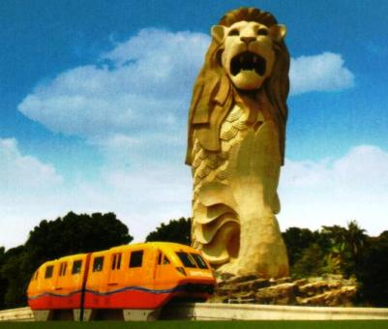
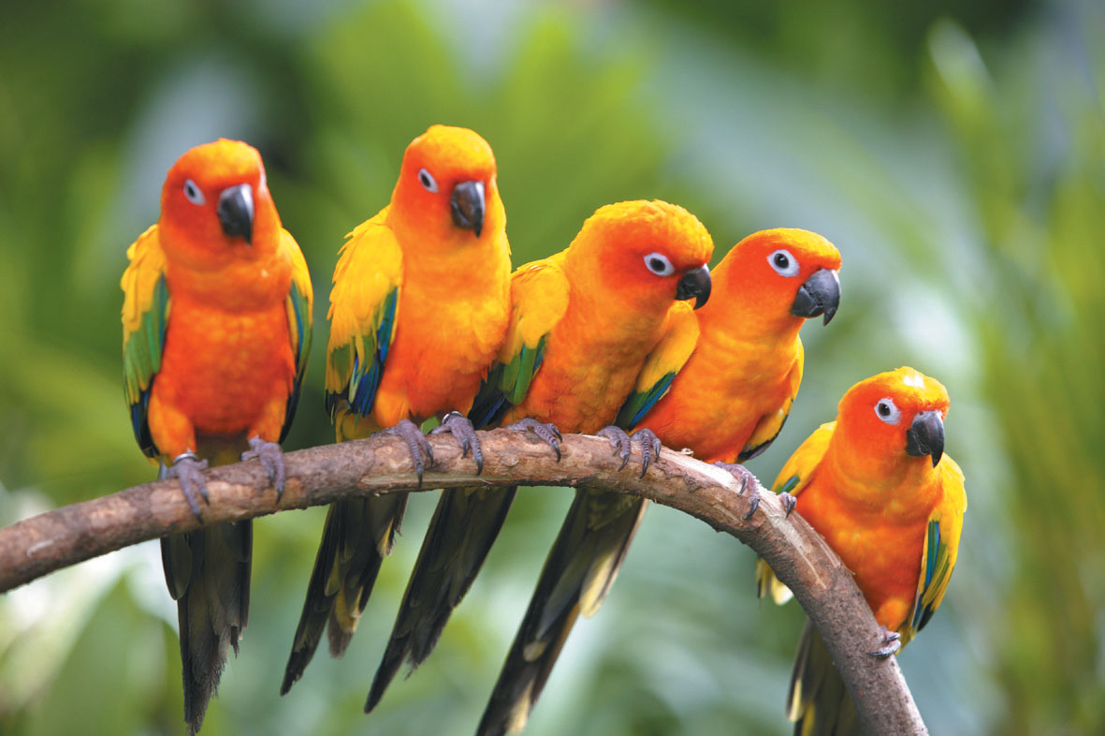

SENTOSA ISLAND:
Sentosa Island is the city-state's most visited attraction. Sentosa Island is just a few hundred yards from the Singapore mainland. Be transported to Sentosa - an island of peace and tranquillity by a scenic cable car ride from Mount Faber. On the island visit Dolphin Lagoon, where you can watch adorable pink dolphins perform their natural antics such as spy-hop, tail-flapping and vocalisations. At Underwater World, you will be taken on a ‘voyage to the bottom of the sea’. Its 80-metre transparent acrylic tunnel allows you to view over 2,500 sea creatures in close proximity. At Images of Singapore, you’ll embark on a journey to experience the colourful culture and vibrant heritage of Singapore, re-told through life-size figures, animatronics and special effects. Later, head for Musical Fountain and be enthralled by this state-of-the-art dramatic display of lasers and computer graphics, water jets and fiery flames. The island has an area of 5 square kilometres out of which 70% of the island is covered by secondary rainforest, the habitat of monkeys, lizards, peacocks as well as other native flora and fauna.
Opening Hours: 830am to 11pm daily

Activities in Sentosa:
Butterfly and Insect Kingdom- a bug’s life
Cable Car
Sentosa Luge- a joyride for all ages
Images of Singapore- experience Singapore’s history
Merlion
Carlsberg Sky tower- Singapore’s tallest observatory tower
Sentosa 4D Magix- Southeast Asia’s largest 4Dimesional Theatre
Underwater world
Dolphin lagoon
Songs of the Sea
CineBlast

GMAX REVERSE BUNGEE JUMP:
Singapore’s first ever bungy! Be launched skywards at 200km per hour to a dazzling height of 60 meters! Experience G forces similar to those experienced by astronauts in a rocket launch, all in the safety of the latest G-MAX technology.
5minute walk from Clarke Quay MRT station

Opening Hours:
3pm to 1 am (Mon - Thu)
3pm to 3 am (Fri)
12 noon to 3 am (Sat)
12 noon to 1 am (Sun)

NIGHT SAFARI:
The World’s first Night Safari, set in 40 hectares of secondary jungle adjoining the Singapore Zoo, will unfold the mystery and drama of the tropical jungle after dusk with stunning effect.
See a myriad of nocturnal animals, from fierce predators to timid forest dwellers, in their natural habitat under subtle moon glow lighting. Roam the jungle in the complete safety and comfort of a tram. Your tram ride takes you through the East and West Loop passing by a large reservoir and weaving through selected habitats designed specifically to replicate the natural environment from the Himalayan Foothills to the Southeast Asian Rainforest and Indian Subcontinent.
On completion of the tram ride, your tour guide will lead you on a walking trail where you will be able to view some of the animals at closer quarters.

Opening Hours: 730pm to 12 midnight (last admission at 1100 hrs) daily

SINGAPORE ZOO:
Leave the city behind as we head north to Mandai for a visit to one of the world's top and most beautiful zoos. The Singapore Zoo is spread over 28 hectares and is a haven to over 3,600 mammals, birds and reptiles including some rare and endangered species. It uses natural barriers like streams, rock walls and vegetation to separate animals from visitors creating an "open zoo" effect. You will get to experience this new concept in animal keeping highlighted by beautiful landscaping and very few cages from the comfort of your tram.

Opening Hours: 830 am to 6pm daily

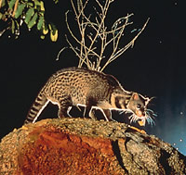
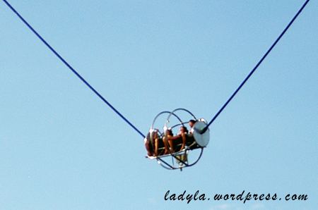

BUKIT TIMAH NATURE RESERVE:
It offers some adventure and thrilling activities. It is paradise for bird and nature lovers. The park is filled with over 800 species of native plants Trek through the jungle via well-marked paths and look out for striking birds, butterflies, monkeys, long-tailed macaques, reticulated pythons, squirrels and flying lemurs, white-bellied sea eagle as well as unique plant life like the insect-eating pitcher plant or climb up Bukit Timah Hill at the core of the reserve – Singapore's highest point at 164 metres above sea level.

LIST OF INDIAN RESTAURANTS

- Moghul Mahal
3D River Valley Road #01-09; Clarke Quay; Singapore 179023,
Tel. 6338 6907

- Bombay Woodlands Restaurant
19, Tanglin Road,
Tel. 62352712

- Annalakshmi Restaurant
#02-10 Excelsior Hotel
Tel. 65 6339 9993

- Jaggis North Indian
34 Race Course Road
Tel. 62960780, 62966141

- Kerala Cuisine
48 Serangoon Road, #01-34 Little India Arcarde
Tel. 6297 1011

- Komala Vilas
12/14 Buffalo Rd Singapore
Tel. 62936980

- Our Village
46 Boat Quay
Tel. 6538 3092, 65383058

- Shayray Punjab
25 Lor Mambong
Tel. 64689126

- Visas
805 Bukit Timah Road, 01-03 Sixth Avenue Centre
Tel. 64623789, 64622910

- Ganges
3A Upper Dickson Road
Tel. 6294 3527

